IMAT3451 FINAL YEAR PROJECT - Global Checklist

The University requires all undergraduate final year projects students to undertake a global review of their project. Here is an International Impact Checklist for you to complete, which can be done in consultation with the project supervisor.

Student Name Programme
Computer science
Mohit Gautam
P15194912

\moh

Project Title

Restaurant table reservation android app. (Table4Me)

Please indicate which of these possible attributes is addressed by your undertaking of this project.
Possible Global Experience | Addressed by Project
Ability to work collaboratively: teams from a range of backgrounds and countries | x
Excellent communication skills with a sensitivity to speaking with and listening to non-native English speakers
An ability to embrace multiple perspectives and challenge thinking in a range of cultural context
A capacity to develop new skills and behaviours according to role requirements | x
An ability to negotiate and influence clients across the globe from different cultures
An ability to form professional, global networks | X
An openness to/respect of a range of perspectives from around the world | x
Multi-cultural learning agility (i.e. able to learn in any culture or environment) | X

Brief description of how the ticked attributes have been addressed
As my application will be a restaurant booking system app, meaning that any different ethnicity restaurant such as Indian, Italian, Mexican, English etc. will be included in the app, as it will be an open platform and will not have any restrictions to anyone.
I will ensure that my app will be available and will work in different countries and cultures without having any bias. I will also ensure that my application will be very user friendly and will contain a ‘help page’ so any body could use it effectively without having to occur with any problems.
However, If there is to be any sort of problem, I will develop an alternative way where users will contact me directly if they have any issues or with my app and where I will be able to take an immediate action.

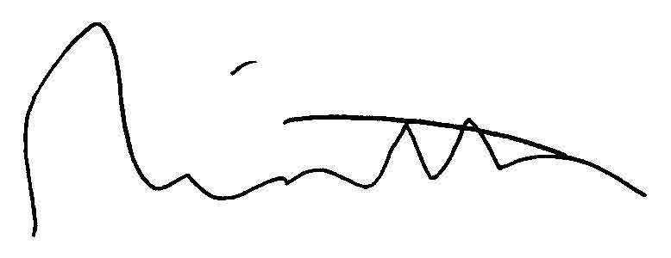
Signature of student 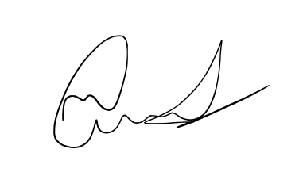 Date-27/10/17

Signature of supervisor Date 27/10/17

